Q1. Write a C# program that prompt the user to input three numbers.The program should then output the numbers in ascending order.

using System;

namespace Sololearn

class Program {

public static void Main(string[]args){

// Accepting the first integer value

Console.WriteLine("Enter the number1: ");

int numb1 =Convert.ToInt32(Console.ReadLine());

// Accepting the second integer value

Console.WriteLine("Enter the number2: ");

int numb2 =Convert.ToInt32(Console.ReadLine());

// Accepting the third integer value

Console.WriteLine("Enter the number3: ");

int numb3 =Convert.ToInt32(Console.ReadLine());

//Sorting the number in ascending order

int[] Arrangement = { numb1, numb2, numb3 };

Array.Sort(Arrangement);

foreach (int a in Arrangement) {

Console.WriteLine(a);

}

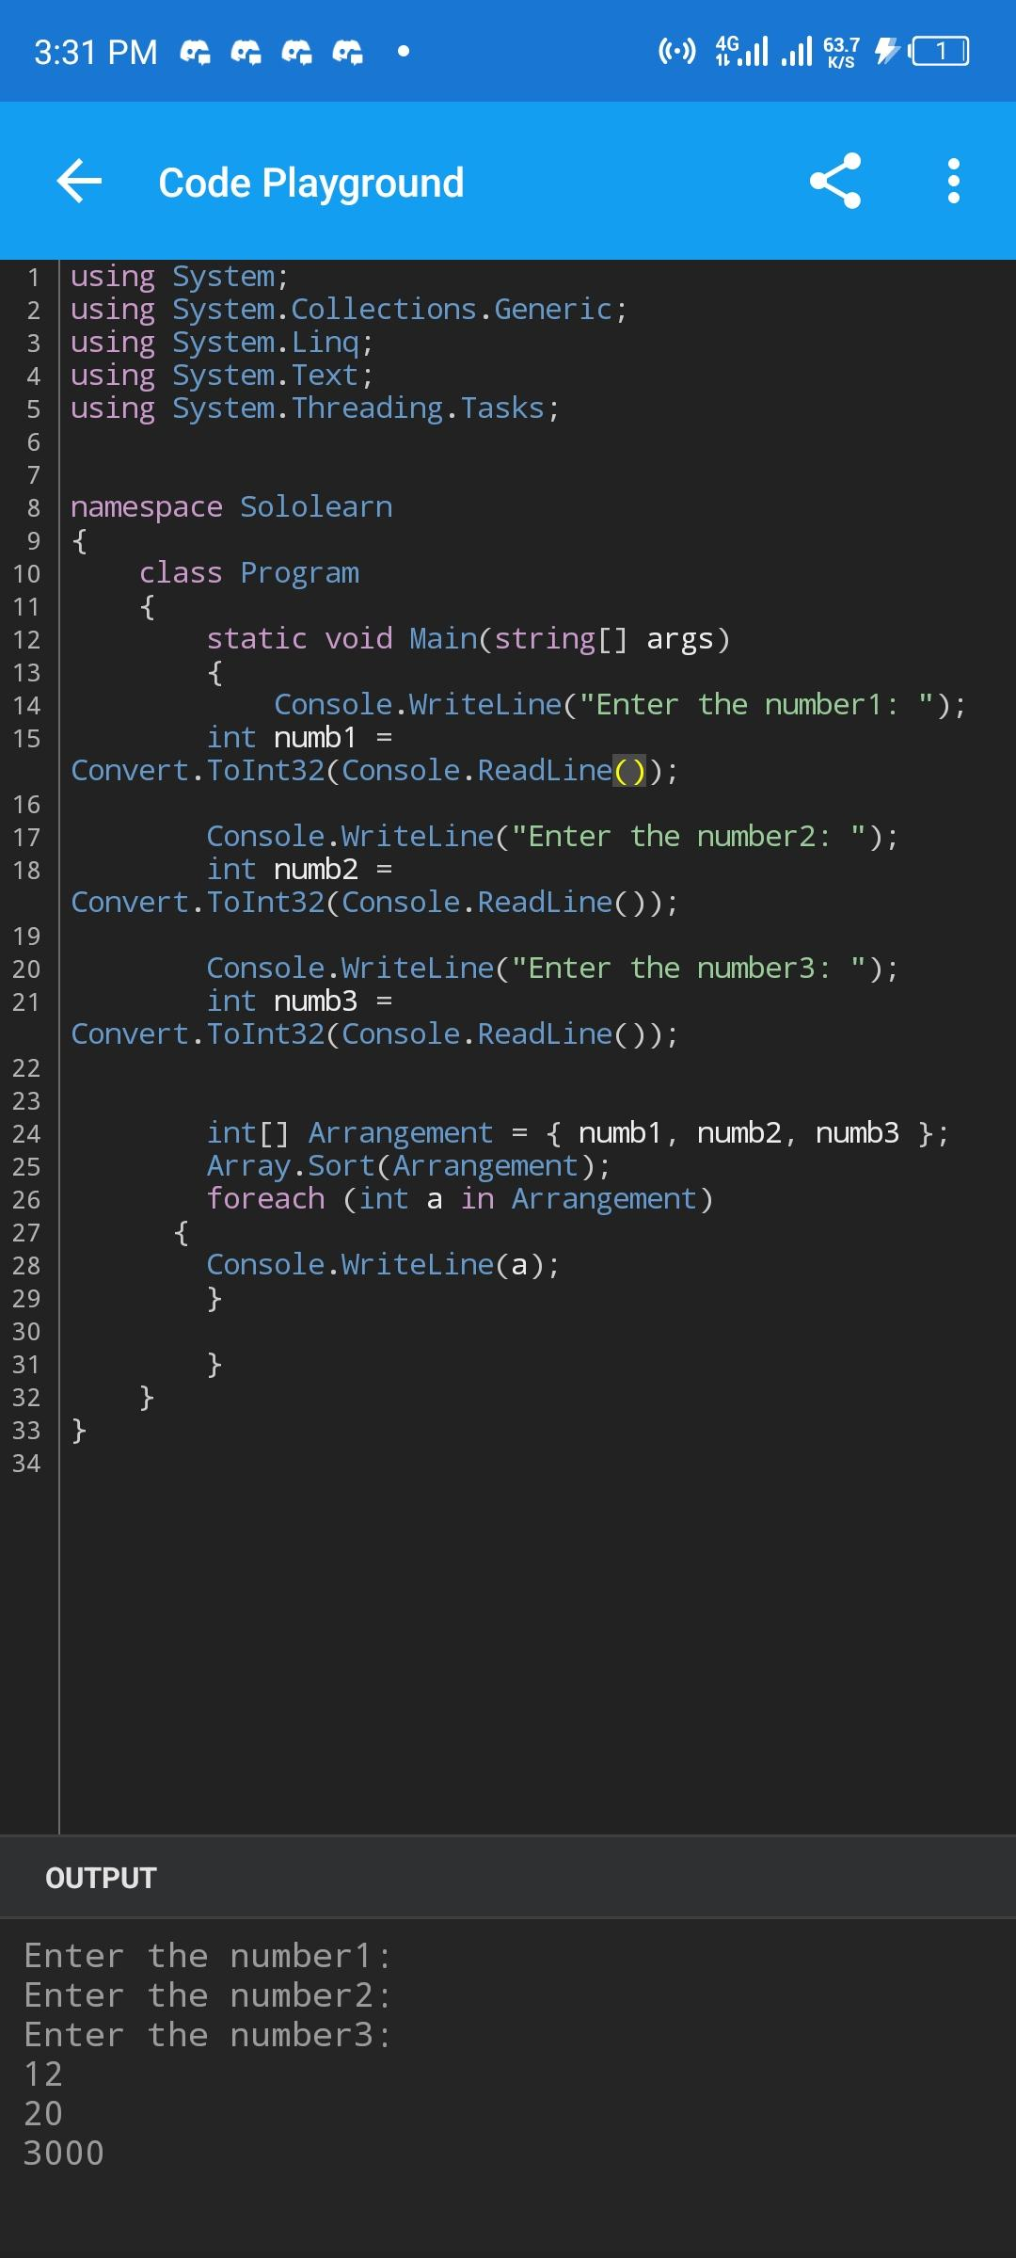

Q3. Write a C# program that prompts the user to input a string and outputs the string in uppercase(Use a character array to store the string)

using System;

using System.Collections.Generic;

using System.Linq;

using System.Text;

using System.Threading.Tasks;

namespace Sololearn {

class Program{

static void Main(string[] args){

Console.WriteLine("Enter a name:");

string Decimal Console.ReadLine();

string DecimalUpper Decimal.ToUpper();

Console.WriteLine("username is " + DecimalUpper );

char[] modes DecimalUpper.ToCharArray();

Console.WriteLine( modes)

}

}

}

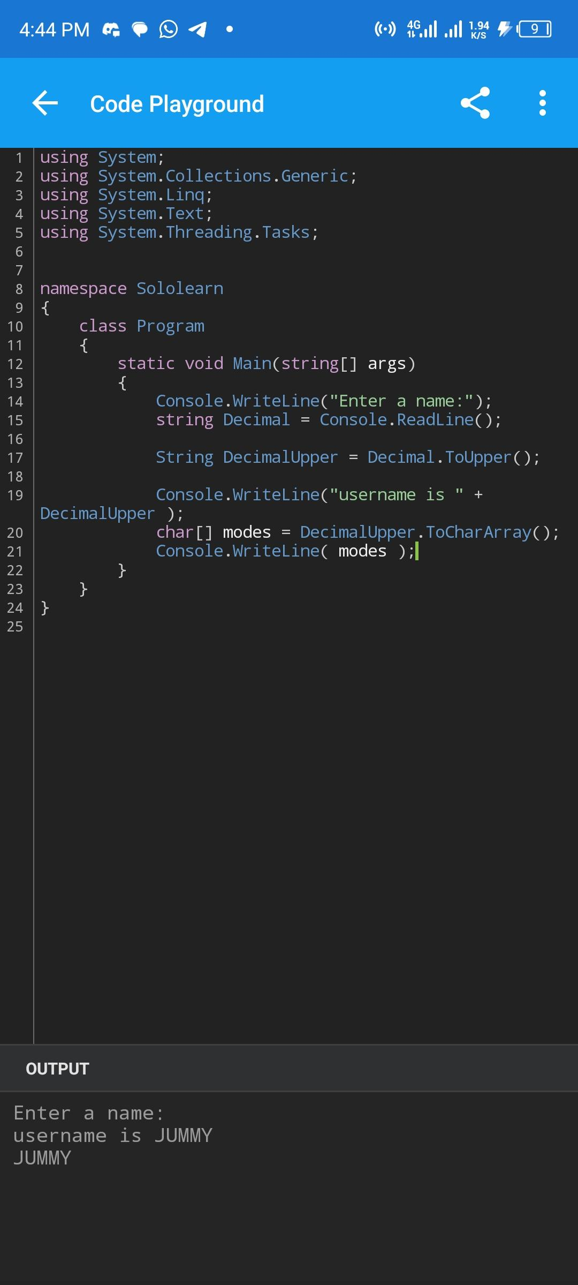

Q6 Write a C# program that prompts the user to input a number. The program should then output the number and a message saying wether the number is positive negative or zero.

using System;

using System.Collections.Generic;

using System.Linq;

using System.Threading.Tasks;

using System.Text;

namespace Sololearn {

class Program{

static void Main(string[] args){

Console.WriteLine("Enter a number: ");

int nomad int.Parse(Console.ReadLine()); if (nomad > 0) {

Console.WriteLine(nomad+" number is positive");

}

else if (nomad < 0)

{

Console.WriteLine(nomad + " number is negative");

}

else

{

Console.WriteLine(nomad + number is zero");

}

